**Assignment- 4**

**Student Name : Dheepan P**

**Student Roll Number 2019504018**

**Maximum Marks: 2 Marks**

**Question: 1.** Write code and connections in wokwi for ultrasonic sensor. Whenever the distance is less than 100 cms send “alert” to IBM cloud and display in the device recent events.

**Solution:**

**WOKWI SHARE LINK:**

**https://wokwi.com/projects/347605806346142290**

**IBM CLOUD IMAGE:**

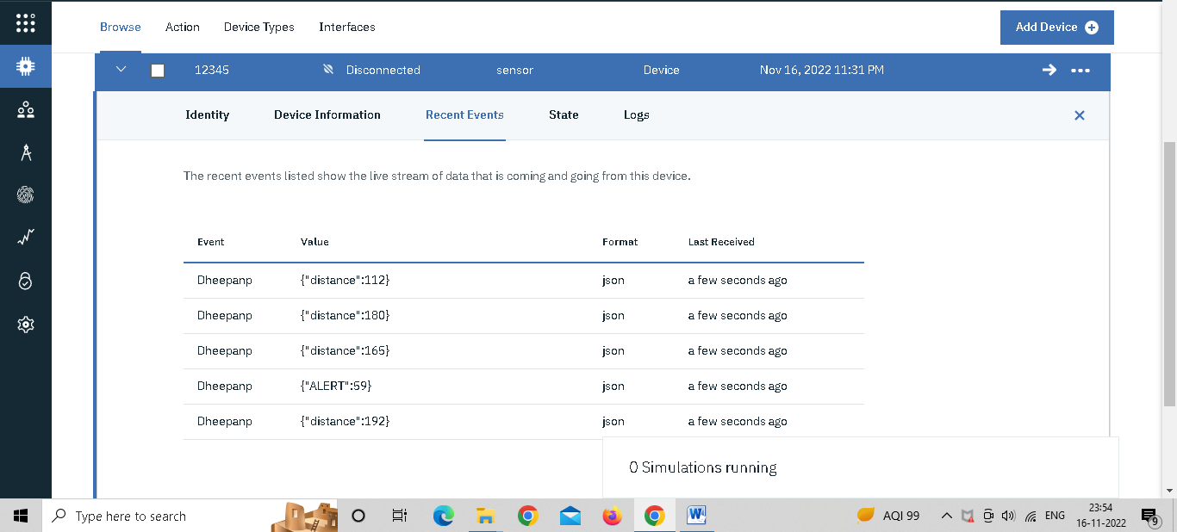

**SIMULATION IMAGE:**

**LED ON:**

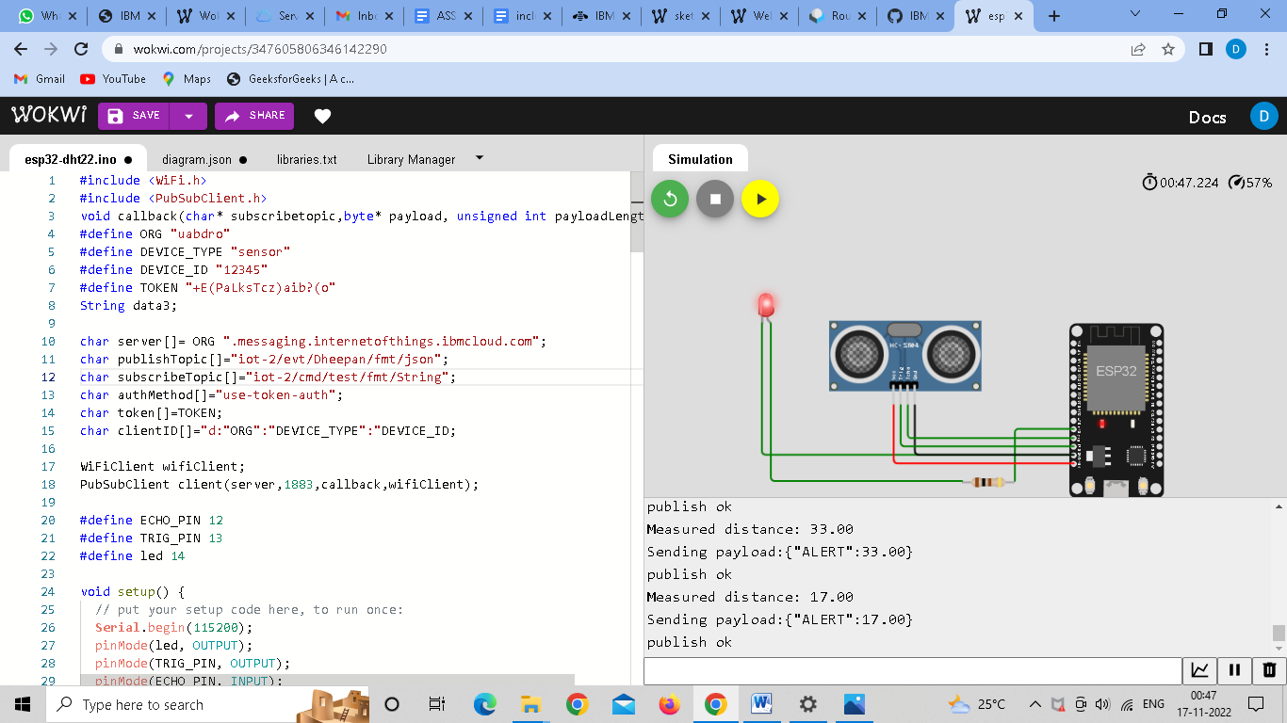

**LED OFF:**

